Moore East Midlands
Oakley House
Headway Business Park
3 Saxon Way West
Corby, NN18 9EZ
T 01536 461900

Moore East Midlands
Rutland House
Minerva Business Park
Lynch Wood
Peterborough, PE2 6PZ
T 01733 397300

www.moore.co.uk

Our ref: 979/770084

24 November 2020

Mrs C Dunk
Checkendon Parish Council
Darent
Beech Lane
Woodcote
Oxfordshire
RG8 0PX

Dear Mrs Dunk

Annual Governance and Accountability Return for the Year ended 31 March 2020

Please find enclosed the signed External Audit Report to accompany your Annual Governance and Accountability Return for the year ended 31 March 2020.

We also enclose a note of our charges based on the fixed rate audit fee as set by the Smaller Authorities’ Audit Appointments Ltd.

Authorities who have not claimed exemption
Regulation 13 of the Accounts and Audit Regulations 2015 stipulate that Authorities, who are not inactive Authorities, must publish the following (including on the Authority’s website):

- The Statement of Accounts and Annual Governance Statement
- The auditor’s certificate and opinion
- Any public interest report or other recommendation of the auditor.
- A form of Notice of Conclusion of Annual Audit

A Notice of Conclusion of Audit form is available, if required, on our website using the link here http://bit.ly/SmallerAuthorities .

The notice must also state that an elector may inspect those documents at all reasonable times and without payment. The address and times when this inspection may be carried out must also be given.

Yours sincerely
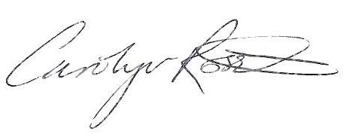
Carolyn Rossiter
carolyn.rossiter@moore.co.uk

Enc.

